4.4 ER Diagram
The diagram Figure 4.4 shows illustrates an Entity-Relationship (ER) model representing a database structure. It defines key entities such as User, Post, Item, Comment, Claim, Location, Category, and Notification, along with their attributes and relationships. The model shows how users create posts, write comments, submit claims, and receive notifications, while items belong to categories and are associated with locations. Overall, it visually maps how data elements interact within the system

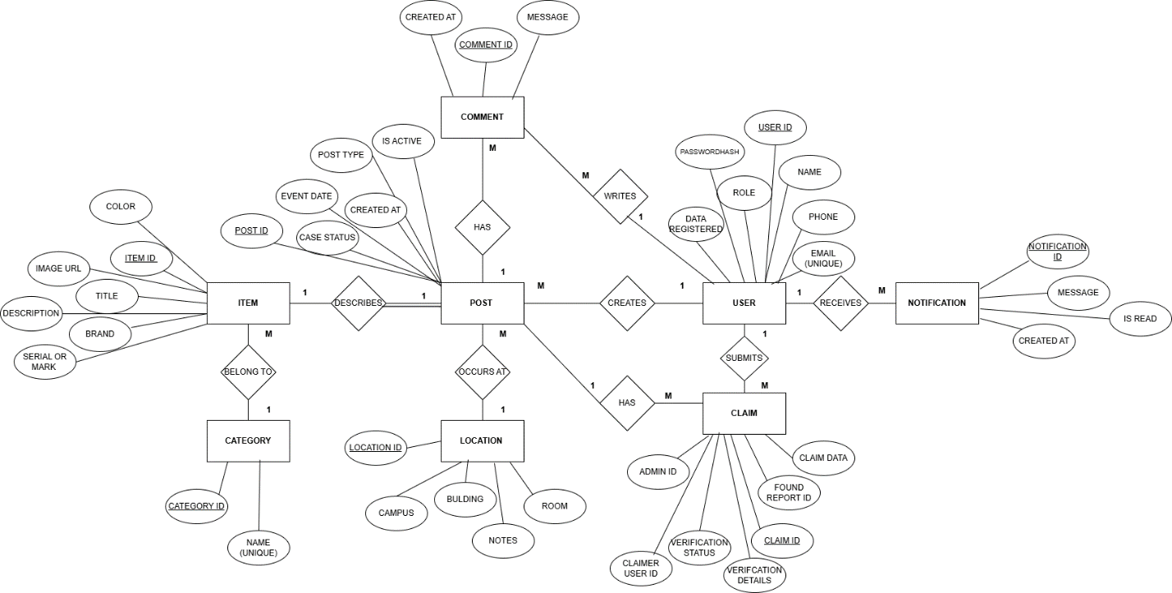

Figure 4.4: ER Diagram for Lost and found board

